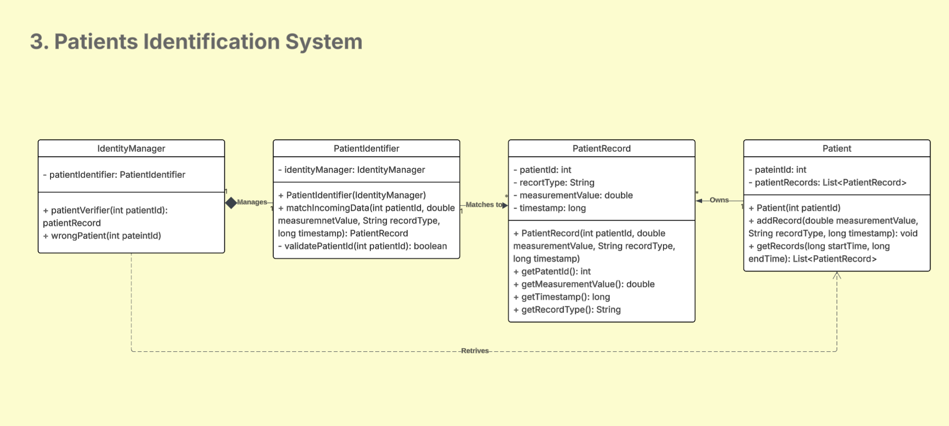

Patients Identification System models a patient identification system ensuring each incoming measurement correctly matches the intended patient. The main design components include:

**IdentityManager**: monitors the entire identification process. It manages an instance of PatientIdentifier. It also retrieves patient information from the Patient class to validate records and maintain data consistency (wrongPatient() method allows for exception management).

**PatientIdentifier**: contains the logic to match incoming data (i.e.: patient ID, measurement, type, and timestamp) to the correct PatientRecord.

**PatientRecord**: maintains a complete, fixed history of all identification events

**Patient**: represents the patient as a whole, owning a list of all their records.